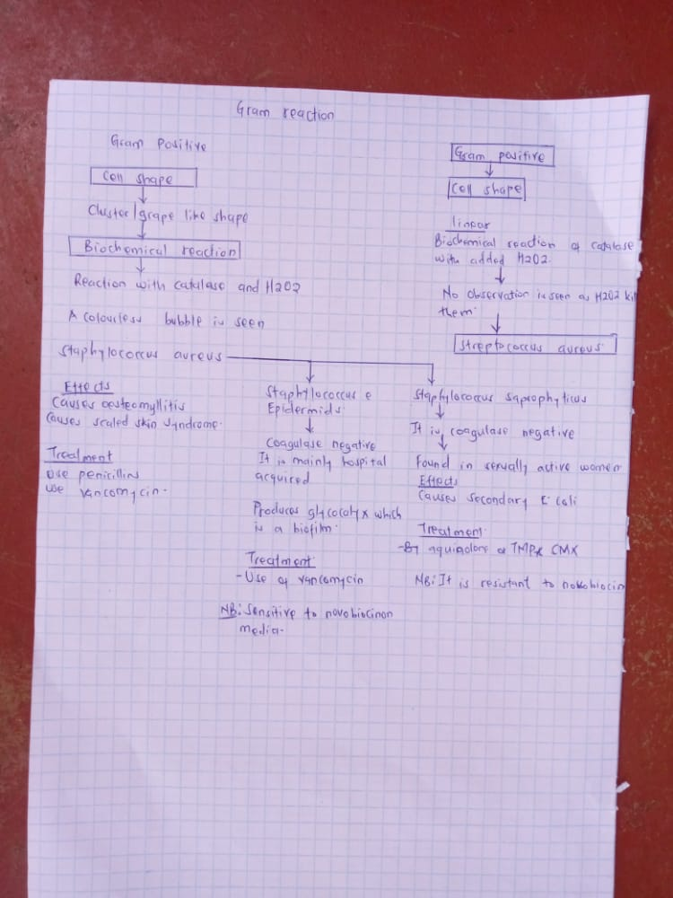
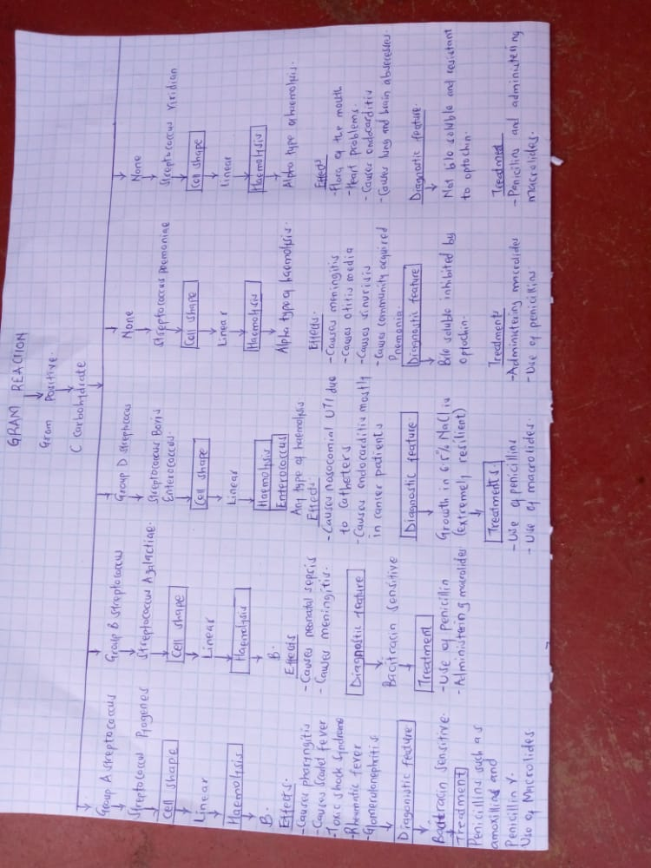
- Assignment Activities
- Review the chart created last week on Gram Positive Cocci. After reviewing the information complete the following:
- Create a dichotomous key including all gram + cocci from the previous week's video
https://youtu.be/hapLalUP8As
After making a chart in the previous week of the gram positive bacilli organisms reviewed in the videos create a dichotomous key using at least 10 different characteristics. Please note: you must view the videos to know which organisms are in play. Make sure this assignment is typed and created as a document.
If you are not familiar with dichotomous keys, you can view different examples of dichotomous keys by googling the topic. This is highly recommended.
A few types of dichotomous keys can be found by researching images of dichotomous keys.
Example 1 (Links to an external site.) 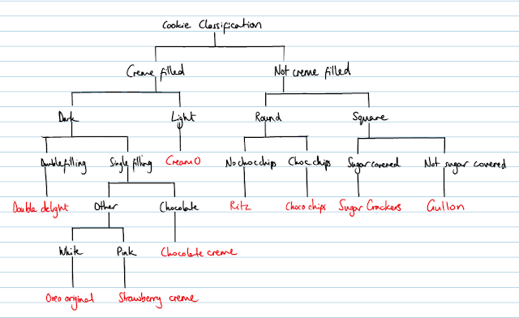
Example 2 (Links to an external site.)
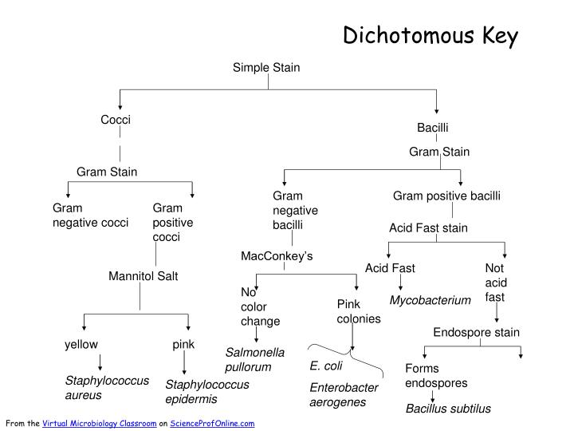

Media (visit media page to click on video or use the link below)
https://youtu.be/UPV94HINJiY (Links to an external site.)
https://youtu.be/HFNbMABbrSI (Links to an external site.)

2.Assignment Activities
- Review the videos and research the organisms reviewed in the videos. I recommend coming up with a chart of various characteristics and indicating where each organism stands in order to get a quick view of all the organism's characteristics at once. The chart is for your use only. After reviewing the information complete the following:
Gram Negative Bacillus Organisms
After making a list of the organisms reviewed in the videos, create a dichotomous key using at least 10 different characteristics. Make sure this assignment is typed and created as a document.

